Goals:

* • Demonstrate how to use the Git version control to locally manage an application development process.
* • Understand how to roll back changes to an application.

Tasks:

* • Clone the forked copy of the provided application.
* • Open the codebase for the application.
* Perform some change to the codebase and then use git to publish those changes to GitHub.
* • Rollback the changes and publish to GitHub again.

vi lbg.test.py

79 git status

80 git add lbg.test.py

81 git status

82 git commit -m "comment added to lbg.test.py for sprint 1 task 2"

83 git log

84 git push

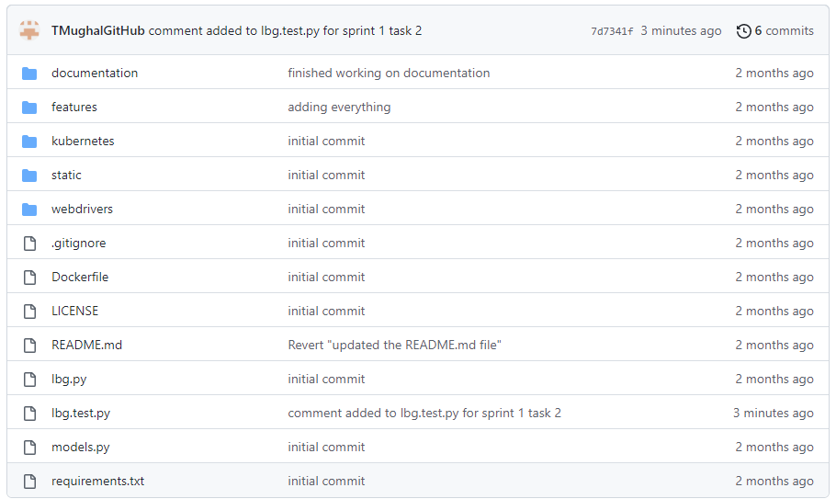

$ git log --oneline

7d7341f (HEAD -> main, origin/main, origin/HEAD) comment added to lbg.test.py for sprint 1 task 2

ca5e125 adding everything

6f40ee7 finished working on documentation

64189bf Revert "updated the README.md file"

d20cc9a updated the README.md file

4f3aa5a initial commit

Admin@840G3 MINGW64 ~/desktop/LBG-Python (main)

$ git revert HEAD

hint: Waiting for your editor to close the file... unix2dos: converting file C:/Users/Admin/Desktop/LBG-Python/.git/COMMIT_EDITMSG to DOS format...

dos2unix: converting file C:/Users/Admin/Desktop/LBG-Python/.git/COMMIT_EDITMSG to Unix format...

[main 986d538] Revert "comment added to lbg.test.py for sprint 1 task 2"

1 file changed, 2 deletions(-)

Admin@840G3 MINGW64 ~/desktop/LBG-Python (main)

$ git status

On branch main

Your branch is ahead of 'origin/main' by 1 commit.

(use "git push" to publish your local commits)

nothing to commit, working tree clean

Admin@840G3 MINGW64 ~/desktop/LBG-Python (main)

$ git push

Enumerating objects: 5, done.

Counting objects: 100% (5/5), done.

Delta compression using up to 4 threads

Compressing objects: 100% (3/3), done.

Writing objects: 100% (3/3), 335 bytes | 335.00 KiB/s, done.

Total 3 (delta 2), reused 0 (delta 0), pack-reused 0

remote: Resolving deltas: 100% (2/2), completed with 2 local objects.

To github.com:TMughalGitHub/LBG-Python.git

7d7341f..986d538 main -> main

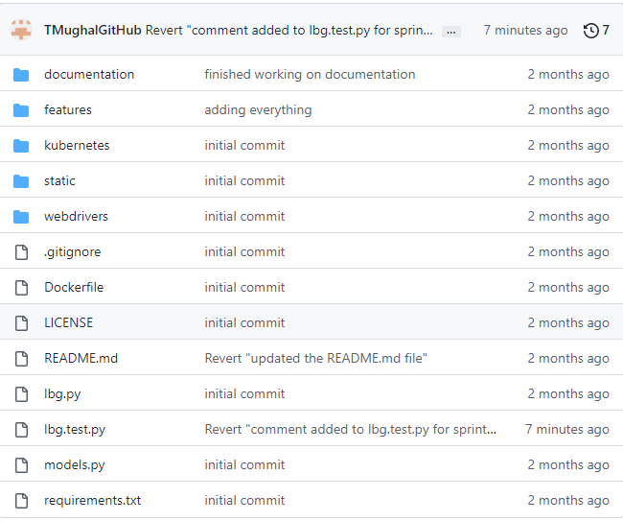

**3. Working with version control branches**

Goals:

* • Demonstrate how to work with Git branches.
* • Create some new files using knowledge of a bash terminal.

Tasks:

* • Using git, create a new branch of the application codebase.
* • Using git bash and your new branch, create a new directory called 'documentation'.
* • Add a .gitignore suitable for python .
* • Add a README.md markdown file to the documentation directory.
* • After you finish working on your documentation, merge it back to your main/master branch.
* • Publish your changes to GitHub.

$git branch dev

$git switch dev

$ mkdir docs2

Admin@840G3 MINGW64 ~/desktop/LBG-Python (dev)

$ cd docs2

Admin@840G3 MINGW64 ~/desktop/LBG-Python/docs2 (dev)

$ touch .gitignore

Admin@840G3 MINGW64 ~/desktop/LBG-Python/docs2 (dev)

$ vi README.md

$ cd ..

Admin@840G3 MINGW64 ~/desktop/LBG-Python (dev)

$ git add .

warning: in the working copy of 'docs2/.gitignore', LF will be replaced by CRLF the next time Git touches it

warning: in the working copy of 'docs2/README.md', LF will be replaced by CRLF the next time Git touches it

Admin@840G3 MINGW64 ~/desktop/LBG-Python (dev)

$ git status

On branch dev

Changes to be committed:

(use "git restore --staged <file>..." to unstage)

new file: docs2/.gitignore

new file: docs2/README.md

Admin@840G3 MINGW64 ~/desktop/LBG-Python (dev)

$ git commit -m "added new folder docs2"

[dev e58c8b6] added new folder docs2

2 files changed, 161 insertions(+)

create mode 100644 docs2/.gitignore

create mode 100644 docs2/README.md

Admin@840G3 MINGW64 ~/desktop/LBG-Python (dev)

$ git switch main

Switched to branch 'main'

Your branch is up to date with 'origin/main'.

$ git merge dev

Updating 986d538..e58c8b6

Fast-forward

docs2/.gitignore | 160 +++++++++++++++++++++++++++++++++++++++++++++++++++++++

docs2/README.md | 1 +

2 files changed, 161 insertions(+)

create mode 100644 docs2/.gitignore

create mode 100644 docs2/README.md

Admin@840G3 MINGW64 ~/desktop/LBG-Python (main)

$ git push

Enumerating objects: 6, done.

Counting objects: 100% (6/6), done.

Delta compression using up to 4 threads

Compressing objects: 100% (4/4), done.

Writing objects: 100% (5/5), 1.83 KiB | 936.00 KiB/s, done.

Total 5 (delta 1), reused 0 (delta 0), pack-reused 0

remote: Resolving deltas: 100% (1/1), completed with 1 local object.

To github.com:TMughalGitHub/LBG-Python.git

986d538..e58c8b6 main -> main

Admin@840G3 MINGW64 ~/desktop/LBG-Python (main)

$ git status

On branch main

Your branch is up to date with 'origin/main'.

nothing to commit, working tree clean

